 | National University  of Computer and Emerging Sciences  Chiniot-Faisalabad Campus | 

COMPUTER ORGANIZATION & ASSEMBLY LANGUAGE
ASSIGNMENT 3
FALL 2023

General Guidelines

General Guidelines

- Follow the deadline mentioned on Google Classroom.
- Attach Screenshots of your AFD debugger. Otherwise, you will lose marks.

Total Marks: 05 Abs
QUESTION 1: Write an assembly program that take a positive integer and checks if it's a palindrome or not. Without using functions and stack.
Answer:
[org 0x0100]

jmp start

data: dw 1771

start: mov ax,[data]
mov cx,0

lab1: mov bl,10
div bl
add cl,ah
mov ah,0
cmp ax,0
je find

mov dx,cx

multip: add cx,dx ; Multipliction use adding
dec bl
cmp bl,1
jne multip
jmp lab1

find: mov ax,[data]
cmp cx,[data] ; if its equal then Zero Flag will be set
; if Zero Flag is 1 then its Palindrome else not

mov ax,0x4c00
int 21h
Screenshot:
You Can see:
if Zero Flag is 1 then its Palindrome else not Palindrome in this case zero flag
is set to 1 it means “1771” is Palindrome number.
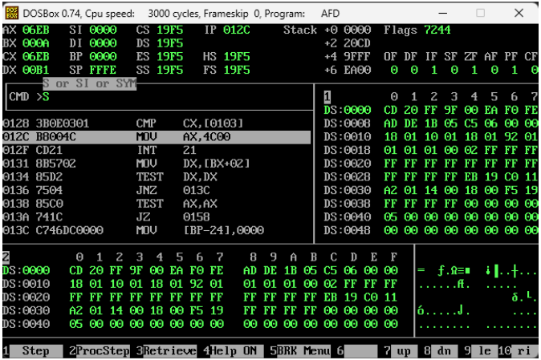

QUESTION 2: Write an assembly program to calculate the factorial of the number. Use loops to do this task. Without using functions and stack.
Answer:
[org 0x0100]

jmp start

num1: dw 6
result: dw 6

start: mov bx ,[num1]
mov ax , [result]

check_bx: sub bx,1
mov cx,bx

multip: add [result],ax ; Multipliction use adding

dec cx
cmp cx,1
jne multip

mov ax , [result]

cmp bx,2
jne check_bx

mov ax,0x4c00
int 21h
Screenshot:
You Can see:
The Factorial of “6! = 720 which is 2D0 in hex ” in ax register
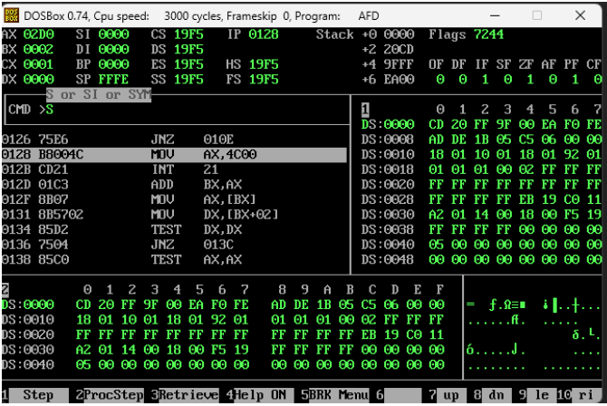
Question 3: Write an assembly program that will change the decimal number into binary. Remember the binary number should be of 8 bits. Use loops to do this. Without using functions and stack.
Answer:
[org 0x0100]
jmp start
num: db 5
result: db 0,0,0,0,0,0,0,0
start:
mov al,byte[num]
mov bx,7
loop1:
shr al,1
jnc noadd
mov byte[result+bx],1
noadd:
mov dl,byte[result+bx]
sub bl,1
cmp bx,1
jae loop1
mov ax,0x4c00
int 0x21
Question 4: Sort the following data in descending order using the bubble sort algorithm: num4: dw 60,55,-55,60,-60, 58, -58, -58, 25, 15,34,87,90,12,65. Give a written dry run of the code and provide a screen capture of the AFD debugger. Also, defend your choice of branches
Answer:
[org 0x0100]
jmp start
num1: dw 60, 55, -55, 60, -60, 58, -58, -58, 25, 15, 34, 87, 90, 12, 65
swap: db 0
start: mov bx, 0
mov byte [swap], 0
labl1: mov ax, [num1+bx]
cmp ax, [num1+bx+2]
jge noswap
mov dx, [num1+bx+2]
mov [num1+bx+2], ax
mov [num1+bx], dx
mov byte [swap], 1
noswap: add bx, 2
cmp bx, 28
jne labl1
cmp byte [swap], 1
je start
mov ax, 0x4c00
int 21h
Screenshot:
You Can see:
The Sorting in descending order below from.” 5A = 90 is the greater number”
